FS F4 – FAS Applications
Oct 18, 2026 · Version 1.1 · @Huy
Function 4 lets School Admin and MOE HQ view FAS applications (MOEFAS and SBFAS), review them and make the final decision. An approved subsidy is applied to the student's EA fees. A rule-based scoring engine (FAS Scoring & Decision Engine) gives each application a Need Score, a suggested tier and a risk level to help the reviewer. It does not decide.
Highlight: yellow = changed from v1.0, green = new in v1.1.
Item | Detail
Function | F4 – FAS applications
Project | Education Account (EA) and FAS website
Portal | Admin Portal
Users | School Admin, MOE HQ
Version | 1.1
Related functions | F5 Upload applications, FAS schemes (scheme setup), F6 Budget & statistics (MOEFAS budget), FAS Scoring & Decision Engine (FASScoreEngine, README 2026-10-14)

1. Introduction

1.1 Scope
In scope | Out of scope
Application list, filters, tabs, summary cards | Uploading paper applications (F5)
Review drawer | Creating and editing schemes (FAS schemes)
Approve and reject | Parent e-Service Portal screens
System updates after a decision | Setting the budget (F6)
ML assessment shown to the reviewer (Need Score, suggested tier, risk) | Training a machine-learning model (the engine is rule-based and deterministic)

1.2 Users and access
Role | What they can do
School Admin | See SBFAS applications of their own school only. Approve or reject them. Only School Admin decides SBFAS.
MOE HQ | See all applications of all schools. Give the final decision on MOEFAS. SBFAS applications are view only for MOE HQ.
MOEFAS applications and income details are visible to MOE HQ only.

1.3 Terms
Term | Meaning
EA | Education Account
FAS | Financial Assistance Scheme
MOEFAS | FAS for Singapore Citizens. Final decision by MOE HQ.
SBFAS | School-based FAS for Citizens and PRs. Decided by School Admin of the student's school.
GHI | Gross household income per month
PCI | Per capita income = GHI / household size
Tier | Level of subsidy: Tier 1 (High need, full), Tier 2 (Medium need, partial), Tier 3 (Low need, partial)
System check | Pass or Fail of the MOEFAS eligibility criteria from the active scheme. Information only.
Need Score | 0–100 score from the FAS Scoring Engine. Higher = more need. See section 5.
Base Tier / Adjusted Tier | Base Tier: from statutory GHI/PCI thresholds. Adjusted Tier: from the Need Score.
ML risk | Low, Medium or High: how likely the family is to have difficulty paying the remaining fees.
Fast-track | The household received public support in the last 3 months.

2. Process flow and statuses

2.1 Flow
Step | MOEFAS | SBFAS
0 | Application is submitted (Online by parent, or Paper uploaded by school). A student who is not a Singapore Citizen cannot get MOEFAS: the application is created as SBFAS for the school directly. All other applications start as MOEFAS.
1 | System runs the eligibility check and saves Pass or Fail for each criterion. The scoring engine computes the Need Score, suggested tier and risk. | Same
2 | Status is Pending. Waits for MOE HQ. Pass and Fail both wait (no automatic approval or rejection). | Status is Pending. Waits for School Admin of the student's school.
3 | MOE HQ approves or rejects. This is the final decision. Approve checks the MOEFAS budget left (BR17). | School Admin approves or rejects. This is the final decision.
4 | If rejected and "Also consider for SBFAS" is Yes: a new SBFAS application is created (Pending) and goes to the school. If No: the application closes as Rejected and the parent gets an email. | End

2.2 Statuses
Status | Meaning | Next status
Pending | Waiting for a decision | Approved, Rejected
Approved | Subsidy granted with a Tier | None (final)
Rejected | Subsidy not granted, with a Reason | None (final)
No other status is shown on screen (no "Auto-granted", "Pending MOE" or "Pending school").

3. Screen: FAS applications list
Menu path: Financial assistance > FAS applications. The page opens on the Pending tab.

3.1 School Admin view
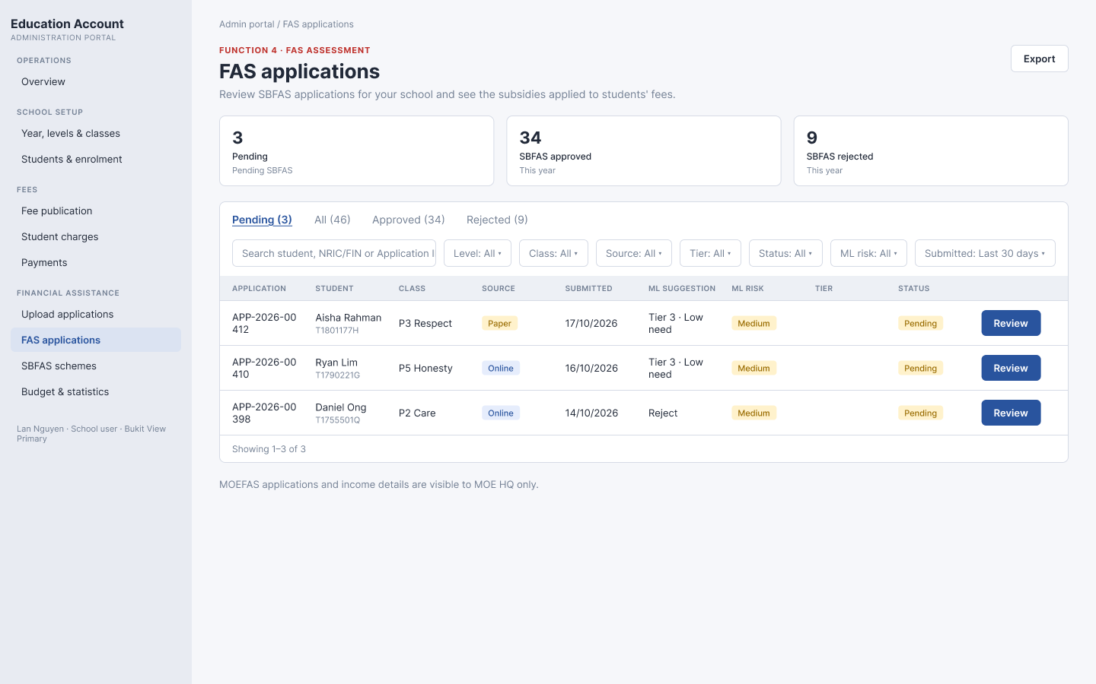
Figure: School Admin – FAS applications list (Pending tab)
# | Element | Type | Behaviour
1 | Export | Button | Downloads a CSV of the filtered list (see 3.4).
2 | Summary cards | Cards | Pending (SBFAS waiting for the school), SBFAS approved (this year), SBFAS rejected (this year). Counts for the user's school. Not affected by filters.
3 | Tabs | Tabs | Pending (default), All, Approved, Rejected. Each tab shows its count when above 0.
4 | Search | Text box | Matches student name, NRIC/FIN or Application ID. Contains, not case sensitive.
5 | Filters | Dropdowns | Level, Class, Source, Tier, Status, ML risk, Submitted. See 3.3.
6 | Table header | Columns | Application, Student, Class, Source, Submitted, ML suggestion, ML risk, Tier, Status. See 3.4.
7 | Review / View | Button | Opens the review drawer (section 4). Review for Pending, View for other statuses.
8 | Footer | Text and pages | Shows "Showing X–Y of Z" and page numbers. 10 rows per page.

3.2 MOE HQ view
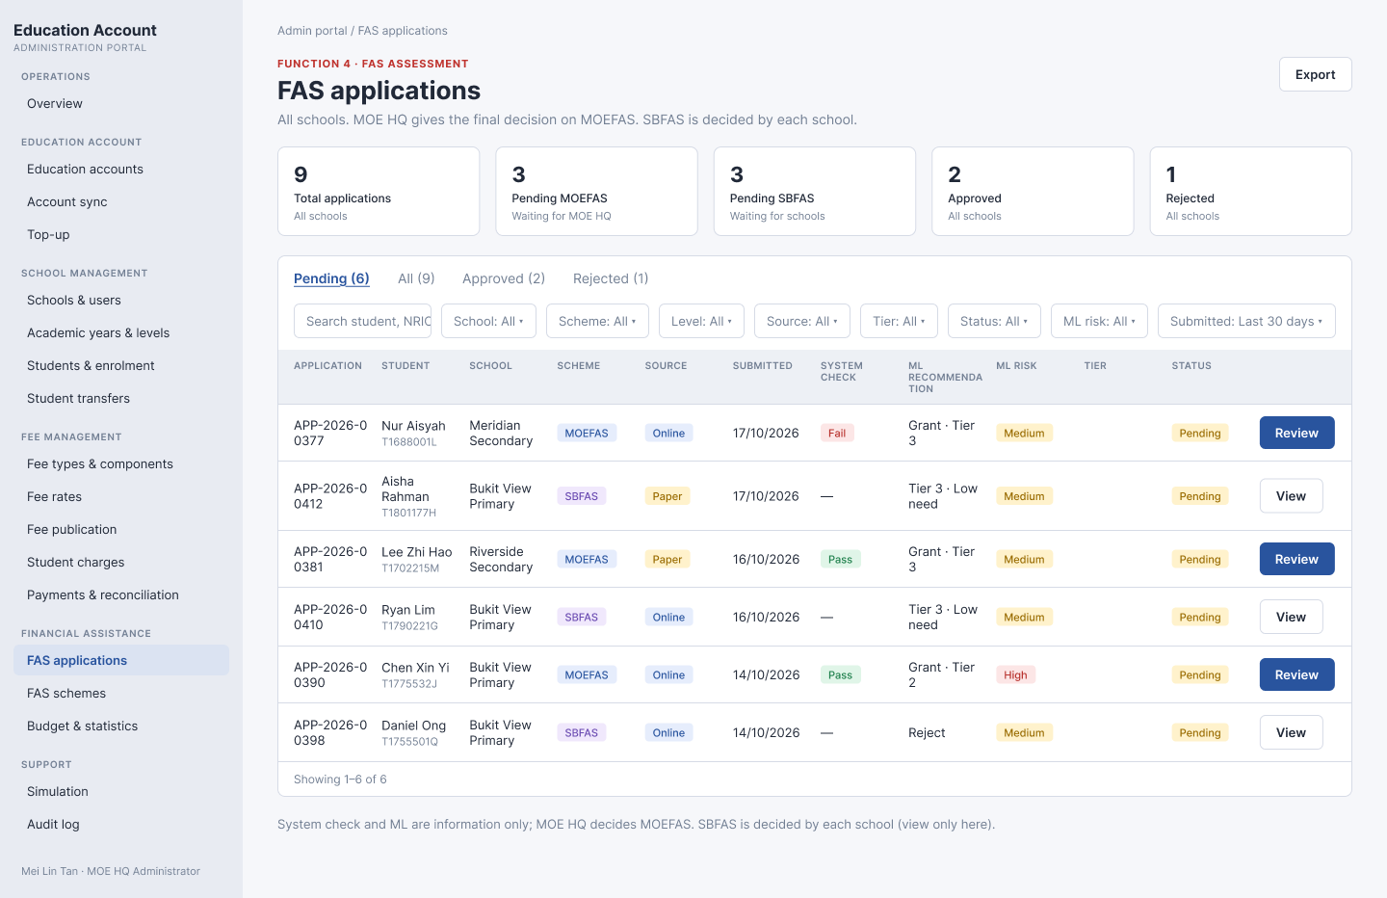
Figure: MOE HQ – FAS applications list (Pending tab)
# | Element | Type | Behaviour
1 | Export | Button | Downloads a CSV of the filtered list (see 3.4).
2 | Summary cards | Cards | Total applications, Pending MOEFAS, Pending SBFAS, Approved, Rejected. All schools. Not affected by filters.
3 | Tabs | Tabs | Pending (default), All, Approved, Rejected. Each tab shows its count when above 0. Pending shows MOEFAS and SBFAS waiting for a decision.
4 | Search | Text box | Same as School Admin.
5 | Filters | Dropdowns | School, Scheme, Level, Source, Tier, Status, ML risk, Submitted. See 3.3.
6 | Table header | Columns | Application, Student, School, Scheme, Source, Submitted, System check, ML recommendation, ML risk, Tier, Status. See 3.4.
7 | Review / View | Button | Review for Pending MOEFAS. View for SBFAS (any status) and decided MOEFAS.
8 | Footer | Text and pages | Same as School Admin.

3.3 Filters
Filters combine with AND. Changing a filter goes back to page 1.
Filter | Values | School Admin | MOE HQ
School | List of schools | No | Yes
Scheme | MOEFAS, SBFAS | No | Yes
Level | Levels of the school (School Admin) or of all schools (MOE HQ) | Yes | Yes
Class | Classes of the school (filtered by Level) | Yes | No
Source | Online, Paper | Yes | Yes
Tier | School Admin: tiers of the school's SBFAS schemes. MOE HQ: MOEFAS, SBFAS – Tier 1/2/3. Decided applications match on their tier; Pending applications match on the ML suggested tier. | Yes | Yes
Status | Pending, Approved, Rejected | Yes | Yes
ML risk | Low, Medium, High | Yes | Yes
Submitted | Last 7 days, Last 30 days (default), Any time | Yes | Yes

3.4 Table columns
Column | School Admin | MOE HQ | Notes
Application | Yes | Yes | Application ID
Student | Yes | Yes | Name, with NRIC/FIN under it
School | No | Yes
Class | Yes | No
Scheme | No | Yes | MOEFAS or SBFAS
Source | Yes | Yes | Online or Paper
Submitted | Yes | Yes | DD/MM/YYYY
System check | No | Yes | MOEFAS: Pass if all criteria pass, otherwise Fail. SBFAS: "—".
ML recommendation / ML suggestion | Yes (ML suggestion) | Yes (ML recommendation) | See 5.4. MOEFAS rows: "Grant · Tier X", "Borderline" or "Do not grant". SBFAS rows: "Tier X · High/Medium/Low need" or "Reject".
ML risk | Yes | Yes | Low, Medium or High (5.3)
Tier | Yes | Yes | Shown when Approved, otherwise empty
Status | Yes | Yes | Pending, Approved or Rejected
CSV export columns: Application, Student, NRIC, School/Class, Scheme, Source, Submitted, System check, ML, ML risk, Tier, Status.

3.5 List behaviour
- Sort: Submitted, newest first.
- Empty result: "No applications found."
- Review shows only to users who can decide that application (see 2.1). Others see View.
- Note under the MOE HQ list: "System check and ML are information only; MOE HQ decides MOEFAS. SBFAS is decided by each school (view only here)."

4. Screen: Review drawer
Review or View opens a side drawer on top of the list. Close it with the X button or by clicking outside. All fields are read-only.
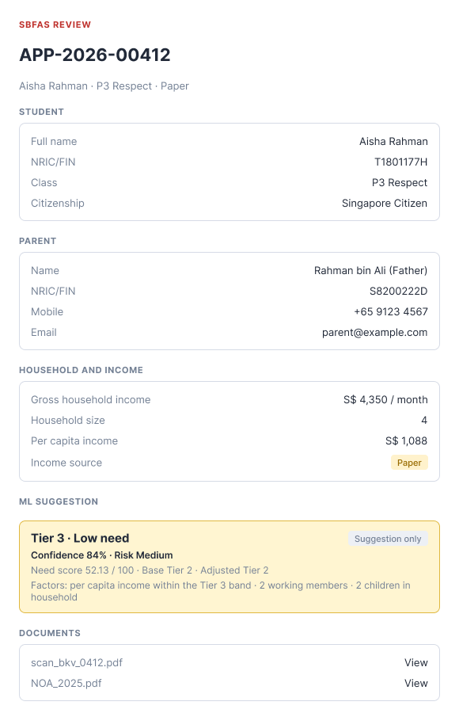
Figure: School Admin – SBFAS review drawer
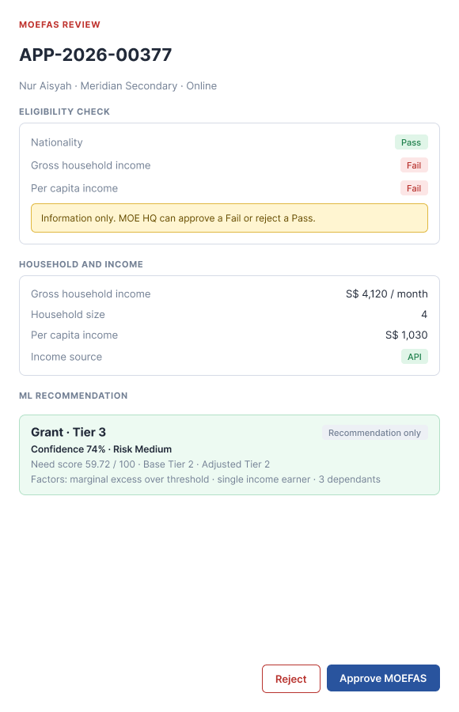
Figure: MOE HQ – MOEFAS review drawer

4.1 Sections by scheme
# | Section | MOEFAS | SBFAS | Behaviour
1 | Header | Yes | Yes | Scheme and "REVIEW", Application ID, then student name, class (School Admin) or school (MOE HQ), and Source. X closes the drawer.
2 | Decision | Decided only | Decided only | See 4.3.
3 | Eligibility check | Yes | No | One row per criterion: value, limit (and % over when above) and Pass or Fail. Limits come from the active scheme. Note: "Information only. MOE HQ can approve a Fail or reject a Pass."
4 | Student | No | Yes | Full name, NRIC/FIN, Class, School (MOE HQ only), Citizenship.
5 | Parent | No | Yes | Name and relationship, NRIC/FIN, Mobile, Email.
6 | Household and income | Yes | Yes | GHI (S$ per month), Household size, PCI (S$), Income source (API or Paper). Income cannot be edited.
7 | ML recommendation (MOEFAS) / ML suggestion (SBFAS) | Yes | Yes | Recommendation or suggestion, tag "Recommendation only" / "Suggestion only", Confidence %, Risk, Need Score, Base Tier, Adjusted Tier, Fast-track (if any), deny rule (if any), Factors, and a collapsible "Score breakdown" (one line per feature: value × weight = contribution). SBFAS: warning when the school has no active SBFAS scheme.
8 | Documents | No | Yes | File name with a View link that opens the file.
9 | History | No | Yes | Date and time and action, oldest first (see 4.4).
10 | Reject / Approve buttons | MOE HQ, Pending | School Admin of the school, Pending | Open the dialogs in section 6. Approve label: "Approve MOEFAS" or "Approve".

4.2 Eligibility criteria shown
Scheme | Criteria
MOEFAS | Nationality is Singapore Citizen. GHI up to S$ 4,000. PCI up to S$ 1,000. GHI and PCI are separate rows. Pass if nationality passes and at least one of GHI or PCI passes (match rule of the active scheme).
SBFAS | Not shown as a section. The SBFAS scheme criteria (Citizen or PR, PCI within the SBFAS band) are used for the ML suggestion.

4.3 Decided application
When the status is Approved or Rejected, the Reject and Approve buttons are hidden and a Decision section shows at the top of the drawer: Result, Tier and Effective from (or Reason), Comment, decided by, and date and time.

4.4 History actions
Uploaded, Submitted, SBFAS application (not a Singapore Citizen), Eligibility check: Pass/Fail · waits for MOE HQ, Approved · Tier X · n fee(s) reduced by S$…, Rejected · Reason, Email with result/reason sent to parent, Moved to SBFAS, Moved to SBFAS from APP-…, Paper application edited.

5. ML assessment (FAS Scoring & Decision Engine)
The engine is rule-based and deterministic. It runs for every application and is shown to the reviewer as information only. It never approves or rejects (BR6, BR19). Weights and cut-offs are configuration, not fixed in the screen.

5.1 Deny rules (checked first)
Rule | Condition
DENY-NO-CHILDREN | No household member under 21
DENY-ONLY-CHILDREN | All household members under 21 (no adult)
DENY-INVALID-SIZE | Household size ≤ 0
DENY-WORKERS-EXCEED-SIZE | Workers > household size
DENY-NEGATIVE-MONTHS | Months since last support < 0
If a deny rule is hit, Need Score = 0 and both tiers are Ineligible. The rule ID is shown in the ML box.

5.2 Need Score
Need Score = 100 × Σ (weight × feature), each feature in [0, 1], weights add up to 1.0.
Feature | Weight | How it is computed
Income | 0.70 | max(x_ghi, x_pci). x_ghi = clamp(1 − GHI/12,000). x_pci = clamp(1 − PCI/3,000). The path used (GHI-driven, PCI-driven, Equal) is logged.
Dependency | 0.05 | (household size − workers) / household size
Stability | 0.10 | Stable 0.20 (3-month / 12-month average 0.70–1.30), Interrupted 0.50 (ratio < 0.70), Unemployed short 0.80 (1–5 zero months), Unemployed long 1.00 (≥ 6 zero months)
Recency | 0.10 | Last support ≤ 3 months 0.90 (Fast-track), 4–12 months 0.50, 13–24 months 0.30, never or > 24 months 0.30
Vulnerability | 0.05 | Sum of: single parent +0.15, elderly member (65+) +0.10, disabled member +0.20, young child (< 6) +0.10. Max 1.0.

5.3 Tiers and risk
Base Tier (statutory, GHI OR PCI) | Adjusted Tier (Need Score) | ML risk
Tier 1: GHI ≤ S$ 4,000 or PCI ≤ S$ 1,000 | Tier 1: 75.00–100 | High
Tier 2: GHI ≤ S$ 5,500 or PCI ≤ S$ 1,375 | Tier 2: 50.00–74.99 | Medium
Tier 3: GHI ≤ S$ 9,000 or PCI ≤ S$ 2,250 | Tier 3: 25.00–49.99 | Low
Tier 4: GHI ≤ S$ 12,000 or PCI ≤ S$ 3,000 | Tier 4: 1.00–24.99 | Low
Ineligible: GHI > S$ 12,000 and PCI > S$ 3,000 | Ineligible: 0 | Low
When the Adjusted Tier shows more need than the Base Tier, the ML box flags it as non-income hardship (evidence for a discretionary decision).

5.4 Recommendation, suggested tier and confidence
- Suggested tier: the tier of the application's scheme (MOEFAS active scheme, or the school's SBFAS scheme) whose band and nationality match. If the income is up to 5% above the scheme limit, the lowest tier is suggested.
- MOEFAS recommendation: "Grant · Tier X" when a tier matches. Up to 5% above the limit: "Grant · lowest tier" if Need Score ≥ 50, otherwise "Borderline". Else "Do not grant".
- SBFAS suggestion: "Tier X · High/Medium/Low need" (need by tier order) or "Reject" when no tier matches.
- Confidence (55–95%): starts at 92, minus 18 if up to 5% above the limit, minus 8 if income is not from API, minus 10 if the name differs from Government data, minus 6 if the household profile is assumed, minus 4 if no tier is suggested.

6. Screen: Approve and reject dialogs
Both dialogs open from the review drawer. The dialog title shows the scheme: "Approve MOEFAS" or "Approve SBFAS". The Comment box is empty by default.

6.1 Approve dialog
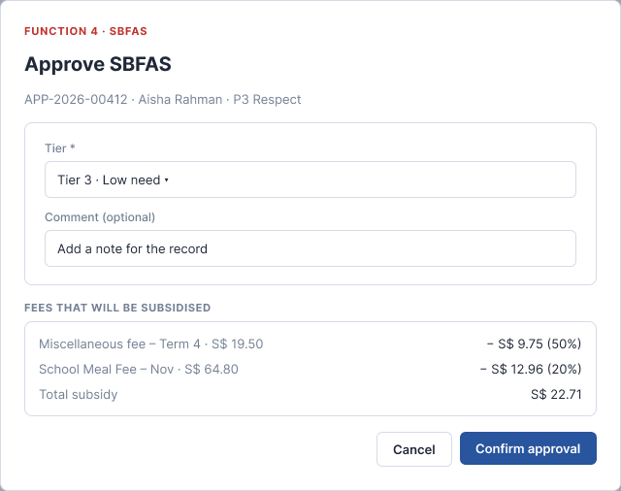
Figure: Approve SBFAS (School Admin)
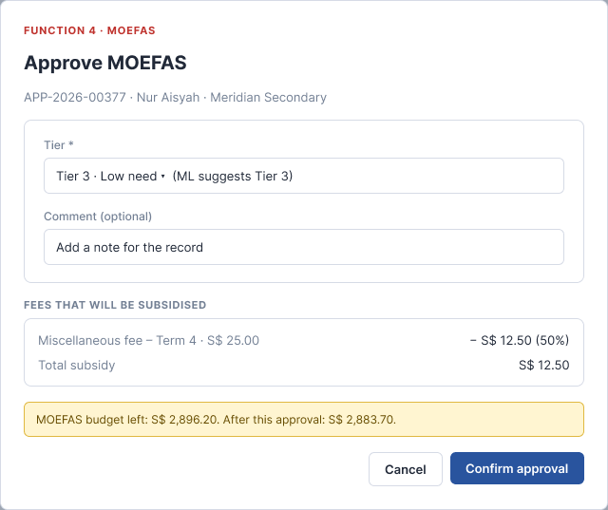
Figure: Approve MOEFAS (MOE HQ) – with Tier and MOEFAS budget note
# | Element | Type | Required | Behaviour
1 | Tier | Dropdown | Yes | Tiers of the scheme: Tier 1 · High need, Tier 2 · Medium need, Tier 3 · Low need. Pre-selected with the ML suggested tier (hint "ML suggests Tier X"); the reviewer can change it. Shown for both MOEFAS and SBFAS.
2 | Effective from | — | — | Not shown. The decision date (today) is used.
3 | Comment | Text box | No | Up to 500 characters. Counter "n/500".
4 | Fees that will be subsidised | Read-only list | - | One row per open fee that the scheme covers: fee name and amount, subsidy (S$ and %). Total subsidy at the bottom. Updates when the Tier changes. If there are no open fees: "No open fees right now. Fees issued later are subsidised automatically."
5 | MOEFAS budget | Note | - | MOEFAS only. "MOEFAS budget left: S$ X. After this approval: S$ Y." If the total subsidy is more than the budget left, a red message shows (section 8) and Confirm approval is disabled.
6 | Cancel | Button | - | Closes the dialog. Nothing is saved.
7 | Confirm approval | Button | - | Disabled when no Tier is selected, the comment is over 500 characters, the scheme has no active version, or the MOEFAS budget is not enough. Saves the decision (section 9).

6.2 Reject dialog
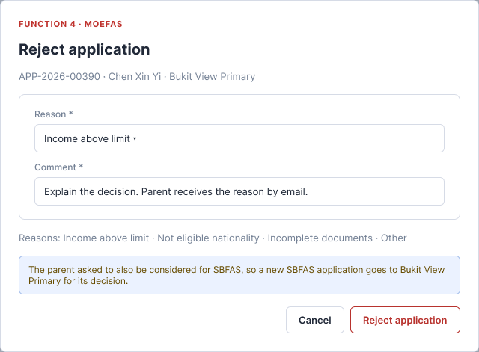
Figure: Reject application (MOEFAS, MOE HQ) – parent asked for SBFAS
# | Element | Type | Required | Behaviour
1 | Reason | Dropdown | Yes | Income above limit, Not eligible nationality, Incomplete documents, Other. Nothing selected by default. The hint under the field lists the same reasons.
2 | Comment | Text box | Yes | Up to 500 characters. Placeholder: "Explain the decision. Parent receives the reason by email."
3 | SBFAS note | Note | - | MOEFAS only. If "Also consider for SBFAS" is Yes: "…a new SBFAS application goes to {school} for its decision." If No: "The parent did not ask for SBFAS. The application closes as Rejected."
4 | Cancel | Button | - | Closes the dialog. Nothing is saved.
5 | Reject application | Button | - | Disabled until Reason and Comment are filled. Saves the decision (section 9).

7. Business rules
ID | Rule
BR1 | MOEFAS always needs the final decision of MOE HQ. The system check and the ML assessment do not approve or reject.
BR2 | SBFAS is decided only by School Admin of the student's school. MOE HQ can view SBFAS but not decide.
BR3 | One decision per application. After Approved or Rejected, the application is read-only.
BR4 | If two users open the same Pending application, the first to confirm wins. The second gets the message in section 8.
BR5 | Eligibility criteria and limits come from the active scheme setup (for example MOEFAS: Citizen, GHI up to S$ 4,000 or PCI up to S$ 1,000). They are not fixed in the screen.
BR6 | The eligibility check is information only. The approver can approve a Fail or reject a Pass.
BR7 | Subsidy % per fee for each Tier comes from the scheme setup.
BR8 | Approve needs a Tier. The Tier is pre-selected with the ML suggestion and can be changed. Comment is optional.
BR9 | Reject needs a Reason and a Comment.
BR10 | Effective from is the decision date (today). The subsidy applies to open fees due on or after it and to new fees.
BR11 | Income is read-only. It cannot be edited in the drawer.
BR12 | MOEFAS rejected by MOE HQ and "Also consider for SBFAS" is Yes: create an SBFAS application with status Pending for the student's school. If No: the application is Rejected and the process ends.
BR13 | School Admin sees only SBFAS applications of their own school. MOEFAS data is never shown to School Admin.
BR14 | Application ID format is APP-YYYY-NNNNN and is unique.
BR15 | Comment: up to 500 characters, plain text.
BR16 | Currency is S$. Date format is DD/MM/YYYY. Time is HH:mm, Singapore time (UTC+8).
BR17 | MOEFAS approval checks the MOEFAS budget (F6): budget left = MOEFAS budget − subsidies already granted. If the total subsidy of this approval is more than the budget left, approval is blocked. No budget set = no limit.
BR18 | A student who is not a Singapore Citizen is not considered for MOEFAS. The application is created as SBFAS for the school.
BR19 | The ML assessment (Need Score, tiers, risk, recommendation, confidence) is information only and is computed by the rule-based engine in section 5. The reviewer always decides.
BR20 | The parent gets an email after every decision: with the Tier when approved, with the Reason when rejected.

8. Validation and messages
Case | Message | Behaviour
Approve without Tier / Reject without Reason or Comment / Comment over 500 characters | Counter "n/500" | Confirm button disabled until fixed.
MOEFAS budget not enough | Not enough MOEFAS budget. This approval needs S$ X but only S$ Y is left. | Confirm approval disabled. Nothing saved.
No active scheme | No active {MOEFAS/SBFAS} scheme. | Confirm approval disabled.
Already decided by someone else | This application was already decided by {user} on {DD/MM/YYYY}. | Dialog closes. Drawer becomes read-only. List refreshes.
School Admin opens an application of another school | You do not have access to this application. | No data shown.
Save fails (system error) | Something went wrong. Please try again. | Nothing is saved. Dialog stays open.
Approved | Subsidy applied to the student's EA fees. | Toast message.
Rejected | Application rejected. Parent notified by email. | Toast message.
Clicking Confirm twice quickly saves the decision once.

9. After a decision
Event | System updates
Approved | Status = Approved. Save Tier, Effective from (today), Comment, decided by, date and time. Apply the subsidy to the student's EA fees (open fees and new fees). Add History rows "Approved · Tier X · n fee(s) reduced by S$…" and "Email with result sent to parent". The subsidy counts towards the MOEFAS/SBFAS granted amount in F6.
Rejected | Status = Rejected. Save Reason, Comment, decided by, date and time. Send an email to the parent with the Reason. Add History rows "Rejected · Reason" and "Email with reason sent to parent".
MOEFAS rejected and "Also consider for SBFAS" is Yes | Create an SBFAS application for the same student, status Pending, visible to the school (History "Moved to SBFAS from APP-…"). Add History row "Moved to SBFAS" on the MOEFAS application.
Any decision | Update summary cards and tab counts. The row leaves the Pending tab. The application becomes read-only.

Where the result shows | What shows
Upload applications list, Status column | Pending, MOEFAS, or SBFAS - Tier 1 / Tier 2 / Tier 3
Parent e-Service Portal, FAS page | Timeline: Submitted, System check, Review by MOE HQ or school, Decision
Parent e-Service Portal, fees page | Fees reduced by the subsidy
Student EA record | Scheme, Tier, Effective from

10. Test scenarios
ID | Scenario | Expected result
T1 | MOE HQ opens the list | Default tab Pending. MOEFAS and SBFAS from all schools. Review on Pending MOEFAS, View on SBFAS.
T2 | School Admin opens the list | Only SBFAS of own school. No School, Scheme or System check column.
T3 | School Admin opens a link to another school's application | "You do not have access to this application."
T4 | School Admin tries to see a MOEFAS application | Not shown anywhere.
T5 | MOE HQ opens a Pending MOEFAS application | Drawer shows eligibility check, income and ML recommendation. Reject and Approve MOEFAS buttons show.
T6 | System check is Fail and MOE HQ approves MOEFAS | Allowed. Status Approved.
T7 | MOEFAS submitted (Pass or Fail) | Status stays Pending until MOE HQ decides. No automatic approval or rejection.
T8 | Open Approve dialog | Tier pre-selected with the ML suggested tier. Fee list shown for that tier.
T9 | Select Tier 2, no comment, confirm | Saved. Status Approved. Fee list matches Tier 2.
T10 | Change Tier in the Approve dialog | Fee list and Total subsidy change.
T11 | Approve MOEFAS when total subsidy is more than the MOEFAS budget left | Red budget message. Confirm approval disabled. Nothing saved.
T12 | Reject without Reason or Comment | Reject application disabled.
T14 | Comment with 501 characters | Confirm disabled. Counter shows 501/500.
T15 | Reject with Reason and Comment | Status Rejected. Parent gets an email with the Reason. Toast "Application rejected. Parent notified by email."
T16 | MOE HQ rejects MOEFAS, "Also consider for SBFAS" is Yes | New SBFAS application, Pending, visible to the school.
T17 | MOE HQ rejects MOEFAS, "Also consider for SBFAS" is No | No new application. MOEFAS Rejected.
T18 | SBFAS decided by School Admin | MOE HQ sees it as Approved or Rejected, read-only.
T19 | MOE HQ opens a Pending SBFAS application | View only. No Approve or Reject buttons.
T32 | Application for a Singapore PR student | Created as SBFAS, Pending for the school. Not shown as MOEFAS.
T20 | Two users confirm the same Pending application | First saves. Second gets the "already decided" message.
T21 | Click Confirm twice quickly | One decision saved.
T22 | Open a decided application | Drawer is read-only. Decision section shows. No buttons.
T23 | Approve an application | Student's EA fees reduced. Parent gets an email.
T24 | Approve or reject | Summary cards and tab counts update. Row leaves the Pending tab.
T25 | Combine filters (Scheme, Status, ML risk, Submitted) | Only rows matching all filters. Page goes back to 1.
T26 | Search by NRIC/FIN, name, Application ID | Matching rows only, not case sensitive.
T27 | Filter with no match | "No applications found."
T28 | More than 10 results | 10 rows per page, newest Submitted first.
T29 | Export with a filter on | CSV has only the filtered rows and the export columns (3.4).
T30 | Save fails | "Something went wrong. Please try again." Nothing saved.
T31 | Dates, times and money | DD/MM/YYYY, HH:mm Singapore time, S$.
T33 | Household with GHI S$ 3,000, size 4, 1 worker, Unemployed short, last support 6 months, elderly member | Need Score 69.75, Adjusted Tier 2, Base Tier 1, ML risk Medium.
T34 | Household with workers more than household size | Deny rule DENY-WORKERS-EXCEED-SIZE shown. Need Score 0. Reviewer can still decide.
T35 | Support received 2 months ago | Fast-track shown in the ML box.

